**Lab Report-01**

*Course Title: Computer Graphics Laboratory*

*Course code: CSE-304*

*3rd Year 1st Semester 2022*

**Date of Submission**: 28-05-2023



**Submitted to-**

***Dr. Mohammad Shorif Uddin***

***And***

***Dr. Morium Akter***

*Department of Computer Science and Engineering*

*Jahangirnagar University*

*Savar, Dhaka-1342*

|  |  |  |  |
| --- | --- | --- | --- |
| **Sl** | Class Roll | Exam Roll | Name |
| 01 | 355 | 202167 | Nuzhat Nairy Afrin |

**1.Scan Conversion of a Point**

**Source Code:**

#include<bits/stdc++.h>

using namespace std;

int main()

{

float x,y;

cout << "Enter point(x,y)" << endl;

cin >> x>>y;

int px,py;

px = floor(x);

py = floor(y);

cout << "Scanned points are ("<<x<<","<<y<<")"<<endl;

}

**Output:**

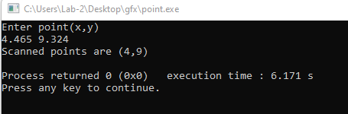

**2.Scan Conversion of a Line Using DDA algorithm**

**Source Code:**

#include<bits/stdc++.h>

#include<graphics.h>

using namespace std;

void drawlinedda(int x1, int y1, int x2, int y2)

{

int dx = x2 - x1;

int dy = y2 - y1;

int steps = abs(dx) > abs(dy) ? abs(dx) : abs(dy);

float xincrement = static_cast<float>(dx) / steps;

float yincrement = static_cast<float>(dy) / steps;

float x = x1;

float y = y1;

for(int i=0; i<=steps; i++)

{

putpixel(static_cast<int>(x),static_cast<int>(y),WHITE);

x += xincrement;

y += yincrement;

}

}

int main()

{

int gd = DETECT, gm;

initgraph(&gd,&gm, "");

int x1,y1,x2,y2;

cout << "Enter first coordinate (x1,y1):" << endl;

cin >> x1 >> y1;

cout << "Enter first coordinate (x2,y2):" << endl;

cin >> x2>>y2;

drawlinedda(x1,y1,x2,y2);

delay(50000000);

closegraph();

return 0;

}

**Output:**

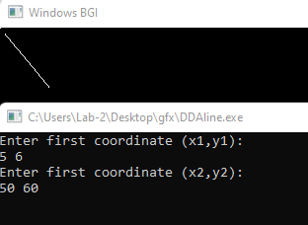

**3.Scan Conversion of a Line Using Bresenham’s Algorithm**

**Source Code:**

#include<bits/stdc++.h>

#include<graphics.h>

using namespace std;

void drawlinebresenham(int x1, int y1, int x2, int y2)

{

int dx = abs(x2 - x1);

int dy = abs(y2- y1);

int sx = (x1 < x2)? 1 : -1;

int sy = (y1 < y2)? 1 : -1;

int err = dx - dy;

while(true)

{

putpixel(x1,y1,WHITE);

if(x1==x2 && y1==y2)

break;

int dt = 2*err;

if(dt>-dy)

{

err -= dy;

x1 += sx;

}

if(dt < dx)

{

err += dx;

y1 += sy;

}

}

}

int main()

{

int gd = DETECT, gm;

initgraph(&gd,&gm, "");

int x1,y1,x2,y2;

cout << "Enter first coordinate (x1,y1):" << endl;

cin >> x1 >> y1;

cout << "Enter first coordinate (x2,y2):" << endl;

cin >> x2>>y2;

drawlinebresenham(x1,y1,x2,y2);

delay(50000000);

closegraph();

return 0;

}

**Output:**

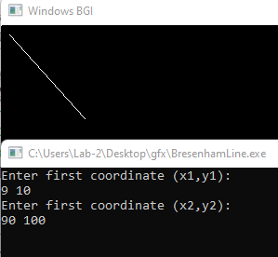

**4.Scan Conversion of a Circle Using Bresenham’s Algorithm**

**Source Code:**

#include<bits/stdc++.h>

#include <iostream>

#include <cmath>

#include <graphics.h>

using namespace std;

void drawCircleBresenham(int xc, int yc, int radius) {

int x = 0;

int y = radius;

int d = 3 - 2 * radius;

while (x <= y) {

putpixel(xc + x, yc + y, WHITE);

putpixel(xc - x, yc + y, WHITE);

putpixel(xc + x, yc - y, WHITE);

putpixel(xc - x, yc - y, WHITE);

putpixel(xc + y, yc + x, WHITE);

putpixel(xc - y, yc + x, WHITE);

putpixel(xc + y, yc - x, WHITE);

putpixel(xc - y, yc - x, WHITE);

if (d < 0) {

d += 4 * x + 6;

} else {

d += 4 * (x - y) + 10;

y--;

}

x++;

}

}

int main() {

int gd = DETECT, gm;

initgraph(&gd, &gm, "");

int xc, yc, radius;

cout << "Enter the coordinates of the center (xc, yc): ";

cin >> xc >> yc;

cout << "Enter the radius of the circle: ";

cin >> radius;

drawCircleBresenham(xc, yc, radius);

delay(5000);

closegraph();

return 0;

}

**Output:**

